# 

# **E & TC Department**

# **A.Y. 2021-22 Semester-II**

|  |
| --- |
| **Problem statement:** Design a form for student registration using HTML & CSS tags.  **Date of Performance: 21/3/22**.  **Theme**: Student Registration Form Webpage using HTML & CSS. |

# **ET-A Batch A1**

# **GROUP 6**

|  |  |  |
| --- | --- | --- |
| **Gr No** | **Roll No:** | **Name** |
| 11910109 | 3 | Anant Abhyankar |
| 12020074 | 16 | Ali Aslam |
| 11910008 | 25 | Ankush Chadgal |

**OUTPUT**

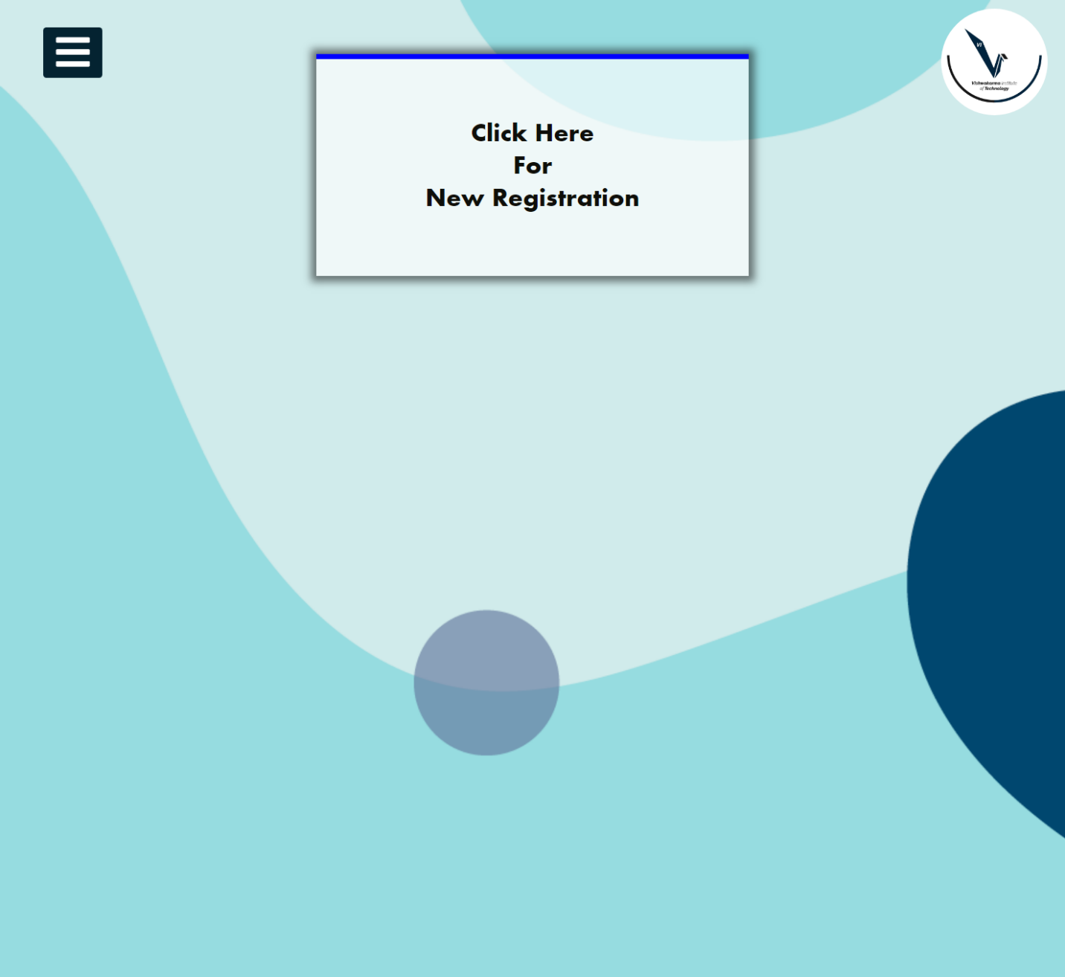

MENU BAR

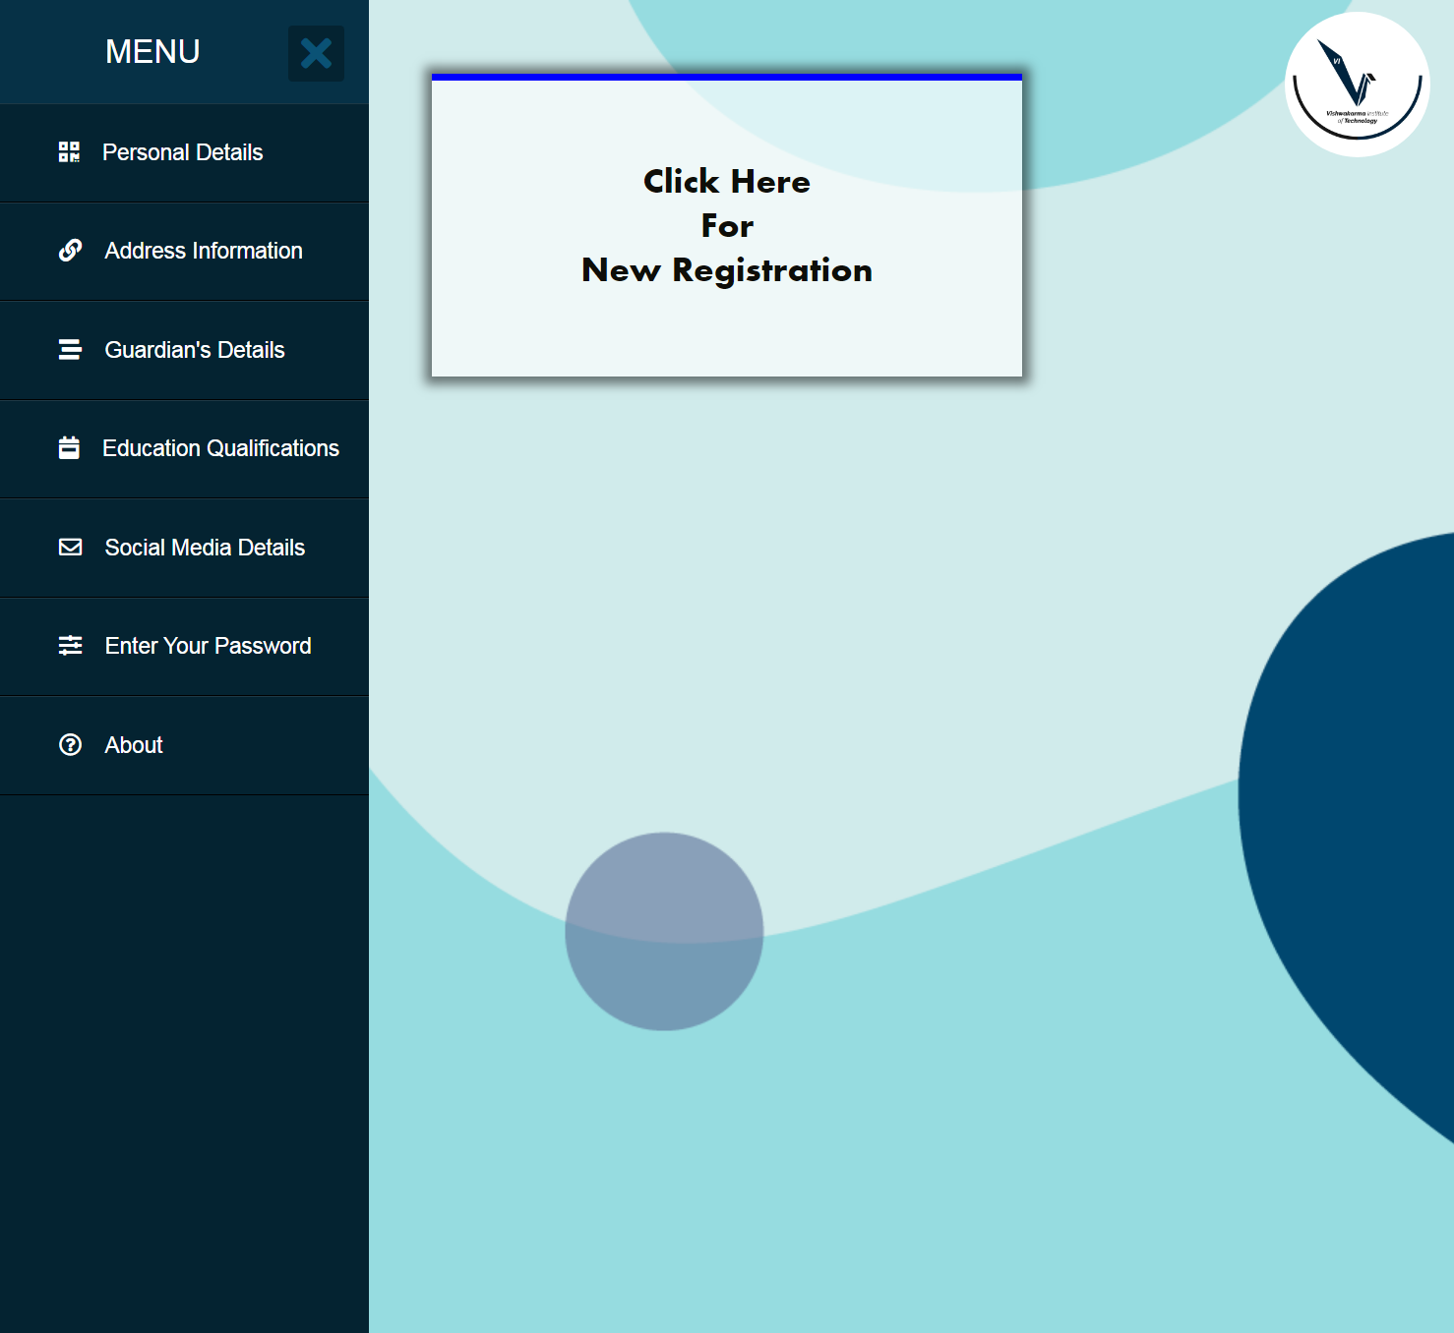

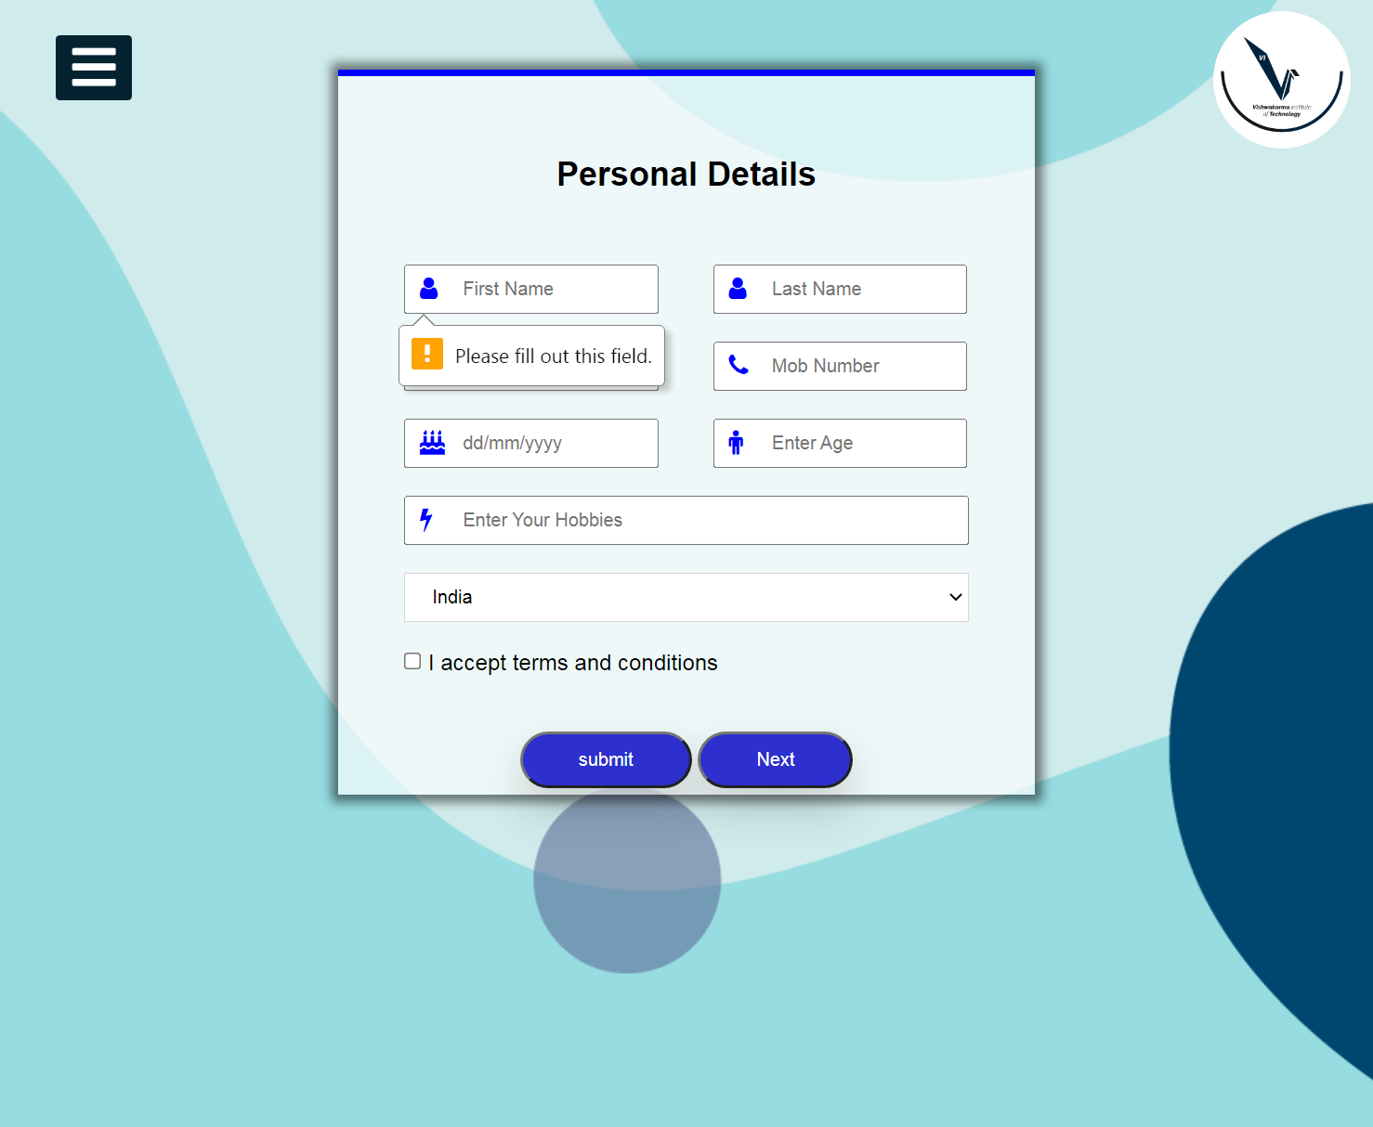

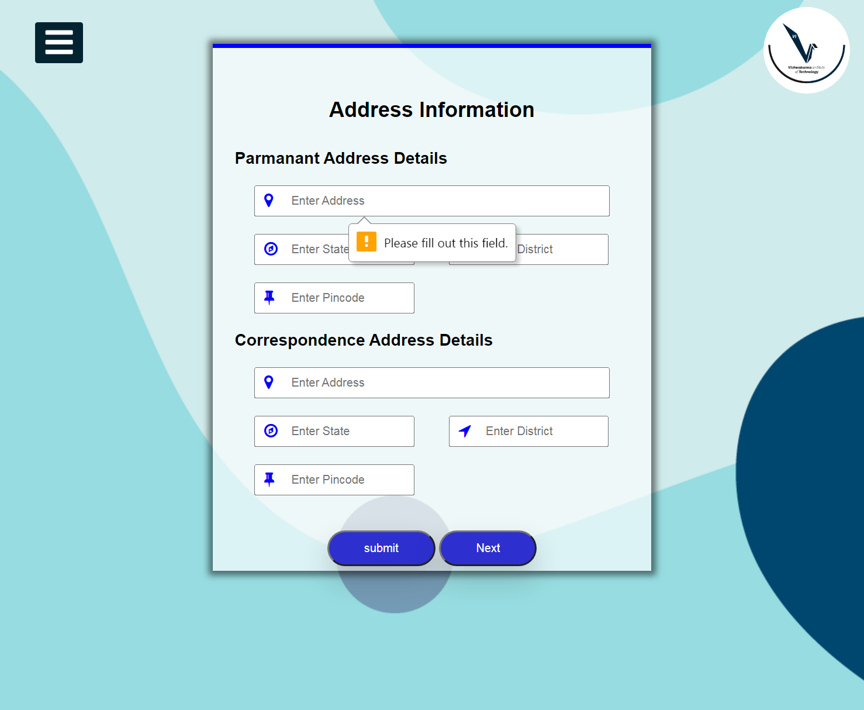

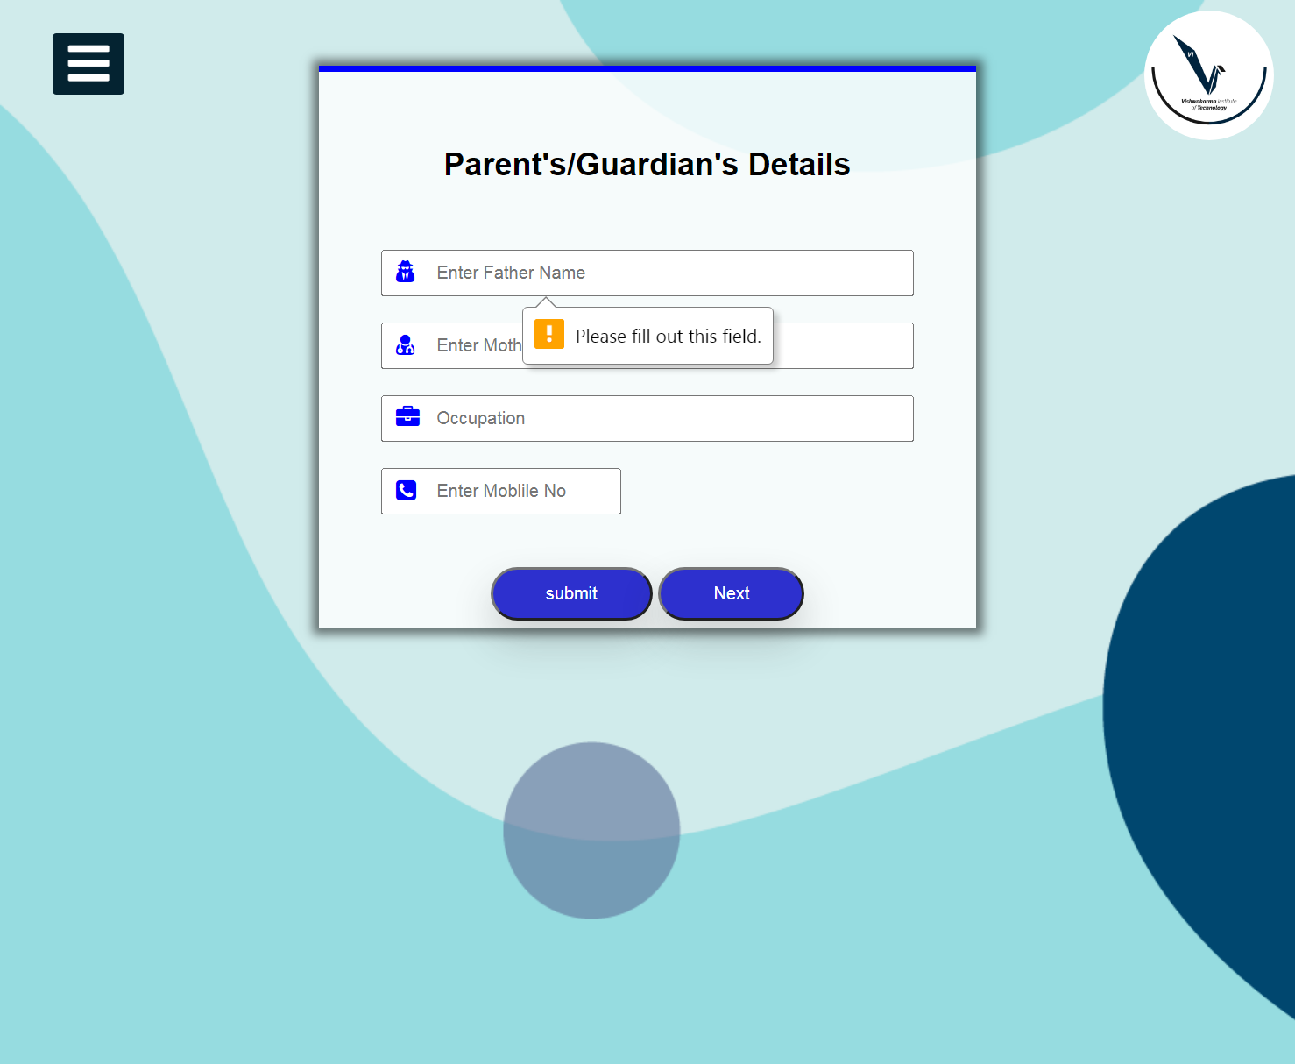



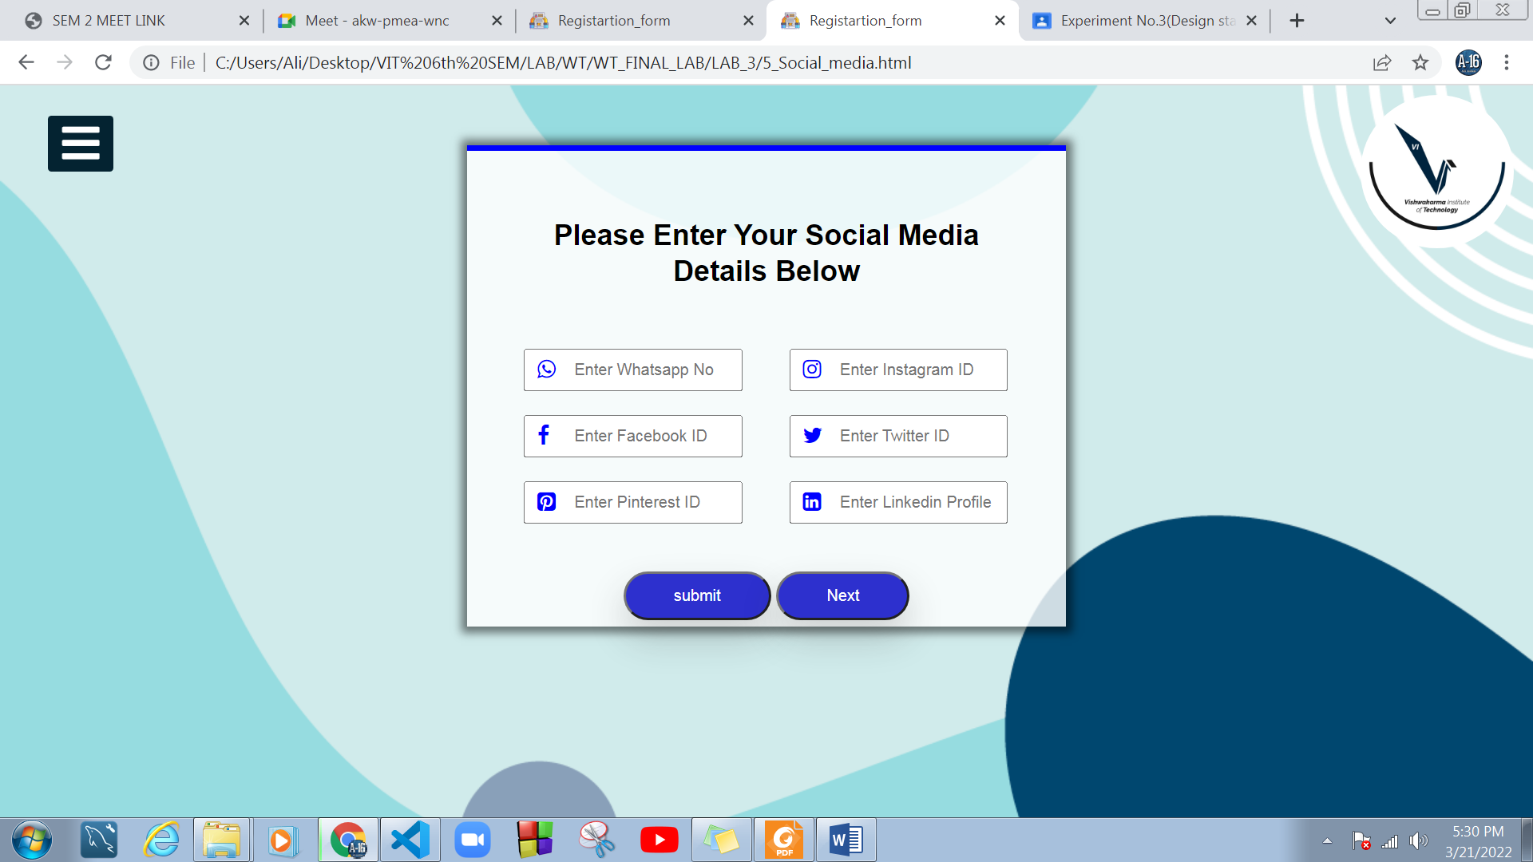

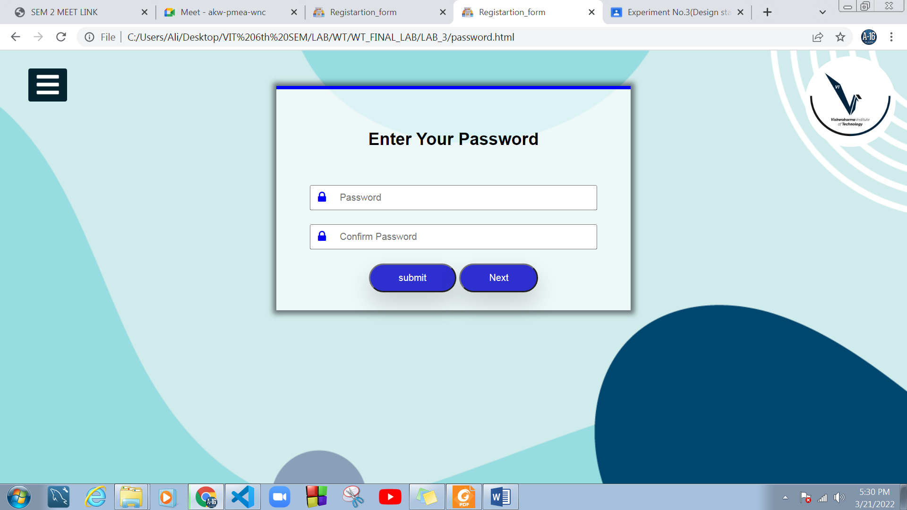

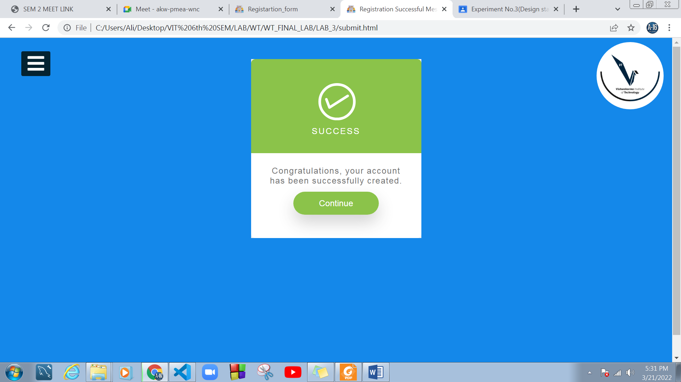

**CODE**

## Menu

**#html_file**

<!DOCTYPE html>

<html lang="en">

<head>

<link rel="stylesheet" href="https://cdnjs.cloudflare.com/ajax/libs/font-awesome/5.15.3/css/all.min.css" />

<link rel="icon" href="https://cdn-icons-png.flaticon.com/512/2718/2718413.png" />

<meta charset="UTF-8" />

<meta http-equiv="X-UA-Compatible" content="IE=edge" />

<meta name="viewport" content="width=device-width, initial-scale=1.0" />

<title>Registartion_form</title>

<link rel="stylesheet" href="test.css" />

<!-- Add icon library -->

<link rel="stylesheet" href="https://cdnjs.cloudflare.com/ajax/libs/font-awesome/4.7.0/css/font-awesome.min.css" />

</head>

<body>

<!-- START MENU -->

<div class="main">

<input type="checkbox" id="check" />

<label for="check">

<i class="fas fa-bars" id="btn"></i>

<i class="fas fa-times" id="cancel"></i>

</label>

<img src="https://www.getadmissioninfo.com/uploads/topics/-vishwakarma-institute-of-technology-vit-pune.jpg" class="vitlogo" alt="" />

<div class="sidebar">

<a href="menu.html">

<header>MENU&nbsp;&nbsp;&nbsp;&nbsp;&nbsp;&nbsp;&nbsp; </header>

</a>

<ul>

<li>

<a href="1_student_details.html"><i class="fas fa-qrcode"></i>Personal Details</a>

</li>

<li>

<a href="2_address_information.html"><i class="fas fa-link"></i>Address Information</a>

</li>

<li>

<a href="3_parents_details.html"><i class="fas fa-stream"></i>Guardian's Details</a>

</li>

<li>

<a href="4_past_qulification.html"><i class="fas fa-calendar-week"></i>Education Qualifications</a>

</li>

<li>

<a href="5_Social_media.html"><i class="far fa-envelope"></i>Social Media Details</a>

</li>

<li>

<a href="password.html"><i class="fas fa-sliders-h"></i>Enter Your Password</a>

</li>

<li>

<a href="#"><i class="far fa-question-circle"></i>About </a>

</li>

</ul>

</div>

<!-- END menu -->

<div class="container">

<h2>

<a href="1_student_details.html" id="contBtn">

<li>Click Here</li>

<li>For</li>

<li>New Registration</li>

</a>

</h2>

</div>

</div>

<!-- END menu -->

</body>

</html>

</html>

**#css_file**

* {

margin: 0;

padding: 0;

box-sizing: border-box;

}

/* body {

background-image: url(https://storage.googleapis.com/gd-wagtail-prod-assets/original_images/Design-Guide-IO_2X1.png);

} */

body {

background-image: url("https://cdn.woorise.com/template/wp-content/uploads/sites/62/2021/02/online-registration-background.png");

}

.main {

display: flex;

}

.container {

background-color: rgba(255, 255, 255, 0.671);

width: 400px;

padding: 25px;

margin: 50px auto;

border-top: 5px solid blue;

box-shadow: 0 0 7px 5px rgba(0, 0, 0, 0.5);

}

.container h2 {

font-size: 24px;

line-height: 30px;

padding: 30px;

text-align: center;

}

.container:hover {

list-style: none;

/* position: absolute;

position: inherit; */

text-decoration: none;

background: #1979a9;

color: rgb(5, 5, 5);

/* margin: auto; */

-webkit-box-shadow: 0px 50px 30px rgba(50, 50, 50, 0.21);

-moz-box-shadow: 0px 15px 30px rgba(50, 50, 50, 0.21);

box-shadow: 0px 15px 30px rgba(50, 50, 50, 0.21);

-webkit-transition: all 0.4s ease;

-moz-transition: all 0.4s ease;

-o-transition: all 0.4s ease;

transition: all 0.4s ease;

border-color: rgb(12, 11, 12);

border-width: 10px;

font-family: "Aharoni";

color: rgb(14, 14, 9);

/* background-color: #a9adaa; */

box-shadow: 0 5px rgb(0, 0, 0);

transform: translateY(4px);

}

#contBtn {

list-style: none;

text-decoration: none;

color: rgb(5, 5, 5);

transition: all 0.4s ease;

}

#contBtn li {

font-family: "Aharoni";

color: rgb(14, 14, 9);

}

#contBtn:hover {

background-color: #555555;

}

#contBtn:active {

background-color: #a9adaa;

box-shadow: 0 5px rgb(0, 0, 0);

transform: translateY(4px);

}

/* MANU BAR */

@import url("https://fonts.googleapis.com/css?family=Roboto:300,400,400i,500");

* {

padding: 0;

margin: 0;

list-style: none;

text-decoration: none;

}

body {

font-family: "Roboto", sans-serif;

}

.sidebar {

position: fixed;

left: -250px;

width: 250px;

height: 100%;

background: #042331;

transition: all 0.5s ease;

}

.sidebar header {

font-size: 22px;

color: white;

line-height: 70px;

text-align: center;

background: #063146;

user-select: none;

}

.sidebar ul a {

display: block;

height: 100%;

width: 100%;

line-height: 65px;

font-size: 15px;

color: white;

padding-left: 40px;

box-sizing: border-box;

border-bottom: 1px solid black;

border-top: 1px solid rgba(255, 255, 255, 0.1);

transition: 0.4s;

}

ul li:hover a {

padding-left: 50px;

}

.sidebar ul a i {

margin-right: 16px;

}

#check {

display: none;

}

label #btn,

label #cancel {

position: absolute;

background: #042331;

border-radius: 3px;

cursor: pointer;

}

label #btn {

left: 40px;

top: 25px;

font-size: 35px;

color: white;

padding: 6px 12px;

transition: all 0.5s;

}

label #cancel {

z-index: 1111;

left: -195px;

top: 17px;

font-size: 30px;

color: #0a5275;

padding: 4px 9px;

transition: all 0.5s ease;

}

#check:checked~.sidebar {

left: 0;

}

#check:checked~label #btn {

left: 250px;

opacity: 0;

pointer-events: none;

}

#check:checked~label #cancel {

left: 195px;

}

#check:checked~section {

margin-left: 250px;

}

section {

/* background: url(bg.jpeg) no-repeat; */

background-position: center;

background-size: cover;

height: 100vh;

transition: all 0.5s;

}

.vitlogo {

width: 10%;

border-radius: 50%;

position: absolute;

position: absolute;

top: 8px;

right: 16px;

font-size: 18px;

}

## Personal Details

**#html_file**

<!DOCTYPE html>

<html lang="en">

<head>

<link rel="stylesheet" href="https://cdnjs.cloudflare.com/ajax/libs/font-awesome/5.15.3/css/all.min.css" />

<link rel="icon" href="https://cdn-icons-png.flaticon.com/512/2718/2718413.png" />

<meta charset="UTF-8" />

<meta http-equiv="X-UA-Compatible" content="IE=edge" />

<meta name="viewport" content="width=device-width, initial-scale=1.0" />

<title>Registartion_form</title>

<link rel="stylesheet" href="1_style.css" />

<!-- Add icon library -->

<link rel="stylesheet" href="https://cdnjs.cloudflare.com/ajax/libs/font-awesome/4.7.0/css/font-awesome.min.css" />

</head>

<body>

<div class="main">

<!-- START MENU -->

<input type="checkbox" id="check" />

<label for="check">

<i class="fas fa-bars" id="btn"></i>

<i class="fas fa-times" id="cancel"></i>

</label>

<img src="https://www.getadmissioninfo.com/uploads/topics/-vishwakarma-institute-of-technology-vit-pune.jpg" class="vitlogo" alt="" />

<div class="sidebar">

<a href="menu.html">

<header>MENU&nbsp;&nbsp;&nbsp;&nbsp;&nbsp;&nbsp;&nbsp; </header>

</a>

<ul>

<li>

<a href="1_student_details.html"><i class="fas fa-qrcode"></i>Personal Details</a>

</li>

<li>

<a href="2_address_information.html"><i class="fas fa-link"></i>Address Information</a>

</li>

<li>

<a href="3_parents_details.html"><i class="fas fa-stream"></i>Guardian's Details</a>

</li>

<li>

<a href="4_past_qulification.html"><i class="fas fa-calendar-week"></i>Education Qualifications</a>

</li>

<li>

<a href="5_Social_media.html"><i class="far fa-envelope"></i>Social Media Details</a>

</li>

<li>

<a href="password.html"><i class="fas fa-sliders-h"></i>Enter Your Password</a>

</li>

<li>

<a href="#"><i class="far fa-question-circle"></i>About </a>

</li>

</ul>

</div>

<!-- END menu -->

<div class="container">

<h2>Personal Details</h2>

<div class="form-container">

<form>

<div class="input-name">

<i class="fa fa-user icon"></i>

<input type="text" placeholder="First Name" class="name" name="Name" required />

<span>

<i class="fa fa-user icon"></i>

<input

type="text"

placeholder="Last Name"

class="name"

name="Name"

required

/>

</span>

</div>

<div class="input-name">

<i class="fa fa-envelope icon"></i>

<input type="email" placeholder="email" class="email" name="email" required />

<span>

<i class="fa fa-phone icon"></i>

<input

type="number"

placeholder="Mob Number"

class="name"

name="number"

id="number"

required

/>

</span>

</div>

<div class="input-name">

<i class="fa fa-birthday-cake icon"></i>

<input type="" name="number" id="dob" placeholder=dd/mm/yyyy class="email" required />

<span>

<i class="fa fa-male icon"></i>

<input

type="number"

placeholder="Enter Age"

class="name"

name="number"

id="number"

required

/>

</span>

</div>

<div class="input-name">

<i class="fa fa-bolt icon"></i>

<input type="text" placeholder="Enter Your Hobbies" class="hobbies" name="hobbies" required />

</div>

<div class="input-name">

<select class="country">

<!-- <option>Select a Country</option> -->

<option>India </option>

<!-- <option>Itley</option>

<option>Nepal</option> -->

</select>

</div>

<div class="arrow"></div>

</div>

<div class="input-name">

<input type="checkbox" clas="check-button" />

<label>I accept terms and conditions</label>

</div>

<!-- <div class="input-name">

<input type="submit" clas="button" value="register" /> -->

<center>

<input type="submit" value="submit" id="contBtn" />

<a href="2_address_information.html"><input type="button" value="Next" id="contBtn" /></a>

</center>

</div>

</form>

</div>

</div>

</body>

</html>

**#css_file**

* {

margin: 0;

padding: 0;

box-sizing: border-box;

}

body {

background-image: url("https://cdn.woorise.com/template/wp-content/uploads/sites/62/2021/02/online-registration-background.png");

}

.container {

background-color: rgba(255, 255, 255, 0.671);

/* background: linear-gradient(white); */

width: 500px;

padding: 25px;

margin: 50px auto;

border-top: 5px solid blue;

box-shadow: 0 0 7px 5px rgba(0, 0, 0, 0.5);

}

.container h2 {

font-size: 24px;

line-height: 30px;

padding: 30px;

text-align: center;

}

.input-name {

width: 90%;

position: relative;

margin: 20px auto;

}

.name {

width: 45%;

padding: 8px 0 8px 40px;

}

.email {

width: 45%;

padding: 8px 0 8px 40px;

}

.input-name span {

margin-left: 35px;

}

.text-name {

width: 100%;

padding: 8px 0 8px 40px;

}

.input-name i {

position: absolute;

font-size: 18px;

color: blue;

}

/* hover */

.text-name:hover,

.name:hover,

.email:hover,

.hobbies:hover,

.country:hover {

background-color: #f2f2f2;

}

/* hover */

.icon {

padding: 8px 11px !important;

}

.aalam-level {

display: flex;

margin: 100px;

align-items: center;

justify-content: center;

}

.password {

width: 100%;

padding: 8px 0 8px 40px;

}

#contBtn {

align-items: right;

position: relative;

top: 1.5em;

text-decoration: none;

background: #2d30ce;

color: #fff;

margin: auto;

padding: 0.8em 3em;

-webkit-box-shadow: 0px 15px 30px rgba(50, 50, 50, 0.21);

-moz-box-shadow: 0px 15px 30px rgba(50, 50, 50, 0.21);

box-shadow: 0px 15px 30px rgba(50, 50, 50, 0.21);

border-radius: 25px;

-webkit-transition: all 0.4s ease;

-moz-transition: all 0.4s ease;

-o-transition: all 0.4s ease;

transition: all 0.4s ease;

}

#contBtn:hover {

-webkit-box-shadow: 0px 15px 30px rgba(245, 9, 9, 0.41);

-moz-box-shadow: 0px 15px 30px rgba(9, 139, 31, 0.932);

box-shadow: 0px 15px 30px rgba(50, 50, 50, 0.41);

-webkit-transition: all 0.4s ease;

-moz-transition: all 0.4s ease;

-o-transition: all 0.4s ease;

transition: all 0.4s ease;

transform: translateY(-2px);

}

.gender {

margin-right: 4px;

}

.contBtn:hover {

background-color: red;

motion-rotation: reverse;

}

.country {

display: inline-block;

width: 100%;

height: 35px;

padding: 0px 15px;

cursor: pointer;

border: 1px solid #cccc;

color: #7b7b7b;

background: white;

}

.input-name,

.country {

color: black;

}

.hobbies {

width: 100%;

padding: 8px 0 8px 40px;

}

/* start menu csss */

/* manu bar */

@import url("https://fonts.googleapis.com/css?family=Roboto:300,400,400i,500");

* {

padding: 0;

margin: 0;

list-style: none;

text-decoration: none;

}

body {

font-family: "Roboto", sans-serif;

}

.sidebar {

position: fixed;

left: -250px;

width: 250px;

height: 100%;

background: #042331;

transition: all 0.5s ease;

}

.sidebar header {

font-size: 22px;

color: white;

line-height: 70px;

text-align: center;

background: #063146;

user-select: none;

}

.sidebar ul a {

display: block;

height: 100%;

width: 100%;

line-height: 65px;

font-size: 15px;

color: white;

padding-left: 40px;

box-sizing: border-box;

border-bottom: 1px solid black;

border-top: 1px solid rgba(255, 255, 255, 0.1);

transition: 0.4s;

}

ul li:hover a {

padding-left: 50px;

}

.sidebar ul a i {

margin-right: 16px;

}

#check {

display: none;

}

label #btn,

label #cancel {

position: absolute;

background: #042331;

border-radius: 3px;

cursor: pointer;

}

label #btn {

left: 40px;

top: 25px;

font-size: 35px;

color: white;

padding: 6px 12px;

transition: all 0.5s;

}

label #cancel {

z-index: 1111;

left: -195px;

top: 17px;

font-size: 30px;

color: #0a5275;

padding: 4px 9px;

transition: all 0.5s ease;

}

#check:checked~.sidebar {

left: 0;

}

#check:checked~label #btn {

left: 250px;

opacity: 0;

pointer-events: none;

}

#check:checked~label #cancel {

left: 195px;

}

#check:checked~section {

margin-left: 250px;

}

section {

/* background: url(bg.jpeg) no-repeat; */

background-position: center;

background-size: cover;

height: 100vh;

transition: all 0.5s;

}

.vitlogo {

width: 10%;

border-radius: 50%;

position: absolute;

position: absolute;

top: 8px;

right: 16px;

font-size: 18px;

}

/* end manu css */

## Address Information

**#html_file**

<!DOCTYPE html>

<html lang="en">

<head>

<link rel="stylesheet" href="https://cdnjs.cloudflare.com/ajax/libs/font-awesome/5.15.3/css/all.min.css" />

<link rel="icon" href="https://cdn-icons-png.flaticon.com/512/2718/2718413.png" />

<meta charset="UTF-8" />

<meta http-equiv="X-UA-Compatible" content="IE=edge" />

<meta name="viewport" content="width=device-width, initial-scale=1.0" />

<title>Registartion_form</title>

<link rel="stylesheet" href="2_style.css" />

<!-- Add icon library -->

<link rel="stylesheet" href="https://cdnjs.cloudflare.com/ajax/libs/font-awesome/4.7.0/css/font-awesome.min.css" />

</head>

<body>

<div class="main">

<!-- START MENU -->

<div class="main">

<input type="checkbox" id="check" />

<label for="check">

<i class="fas fa-bars" id="btn"></i>

<i class="fas fa-times" id="cancel"></i>

</label>

<img src="https://www.getadmissioninfo.com/uploads/topics/-vishwakarma-institute-of-technology-vit-pune.jpg" class="vitlogo" alt="" />

<div class="sidebar">

<a href="menu.html">

<header>MENU&nbsp;&nbsp;&nbsp;&nbsp;&nbsp;&nbsp;&nbsp; </header>

</a>

<ul>

<li>

<a href="1_student_details.html"><i class="fas fa-qrcode"></i>Personal Details</a>

</li>

<li>

<a href="2_address_information.html"><i class="fas fa-link"></i>Address Information</a>

</li>

<li>

<a href="3_parents_details.html"><i class="fas fa-stream"></i>Guardian's Details</a>

</li>

<li>

<a href="4_past_qulification.html"><i class="fas fa-calendar-week"></i>Education Qualifications</a>

</li>

<li>

<a href="5_Social_media.html"><i class="far fa-envelope"></i>Social Media Details</a>

</li>

<li>

<a href="password.html"><i class="fas fa-sliders-h"></i>Enter Your Password</a>

</li>

<li>

<a href="#"><i class="far fa-question-circle"></i>About </a>

</li>

</ul>

</div>

<!-- END menu -->

<div class="container">

<h2>Address Information</h2>

<div class="form-container">

<h3>Parmanant Address Details</h3>

<form>

<div class="input-name">

<i class="fa fa-map-marker icon"></i>

<input type="address" placeholder="Enter Address" class="address" name="Name" required />

</div>

<div class="input-name">

<i class="fa fa-compass icon"></i>

<input type="text" placeholder="Enter State" class="name" name="Name" required />

<span>

<i class="fa fa-location-arrow icon"></i>

<input

type="text"

placeholder="Enter District"

class="name"

name="Name"

required

/>

</span>

</div>

<div class="input-name">

<i class="fa fa-thumb-tack icon"></i>

<input type="text" placeholder="Enter Pincode" class="name" name="Name" required />

</div>

<!-- corresponding address -->

<h3>Correspondence Address Details</h3>

<div class="input-name">

<i class="fa fa-map-marker icon"></i>

<input type="address" placeholder="Enter Address" class="address" />

</div>

<div class="input-name">

<i class="fa fa-compass icon"></i>

<input type="text" placeholder="Enter State" class="name" name="Name" required />

<span>

<i class="fa fa-location-arrow icon"></i>

<input

type="text"

placeholder="Enter District"

class="name"

name="Name"

required

/>

</span>

</div>

<div class="input-name">

<i class="fa fa-thumb-tack icon"></i>

<input type="text" placeholder="Enter Pincode" class="name" name="Name" required />

</div>

<center>

<input type="submit" value="submit" id="contBtn" />

<a href="3_parents_details.html"><input type="button" value="Next" id="contBtn" /></a>

</center>

</div>

</form>

</div>

</div>

</body>

</html>

**#css_file**

* {

margin: 0;

padding: 0;

box-sizing: border-box;

}

body {

background-image: url("https://cdn.woorise.com/template/wp-content/uploads/sites/62/2021/02/online-registration-background.png");

}

/* body {

font-size: 14px;

background-color: #f2f2f2f2;

} */

.container {

background-color: rgba(255, 255, 255, 0.671);

background: linear-gradient(white);

width: 500px;

padding: 25px;

margin: 50px auto;

border-top: 5px solid blue;

box-shadow: 0 0 7px 5px rgba(0, 0, 0, 0.5);

}

.container h2 {

font-size: 24px;

line-height: 30px;

padding: 30px;

text-align: center;

}

.input-name {

width: 90%;

position: relative;

margin: 20px auto;

}

.name {

width: 45%;

padding: 8px 0 8px 40px;

}

.email {

width: 45%;

padding: 8px 0 8px 40px;

}

.input-name span {

margin-left: 35px;

}

.text-name {

width: 100%;

padding: 8px 0 8px 40px;

}

.input-name i {

position: absolute;

font-size: 18px;

color: blue;

}

.icon {

padding: 8px 11px !important;

}

.aalam-level {

display: flex;

margin: 100px;

align-items: center;

justify-content: center;

}

.address {

width: 100%;

padding: 8px 0 8px 40px;

}

#contBtn {

position: relative;

top: 1.5em;

text-decoration: none;

background: #2d30ce;

color: #fff;

margin: auto;

padding: 0.8em 3em;

-webkit-box-shadow: 0px 15px 30px rgba(50, 50, 50, 0.21);

-moz-box-shadow: 0px 15px 30px rgba(50, 50, 50, 0.21);

box-shadow: 0px 15px 30px rgba(50, 50, 50, 0.21);

border-radius: 25px;

-webkit-transition: all 0.4s ease;

-moz-transition: all 0.4s ease;

-o-transition: all 0.4s ease;

transition: all 0.4s ease;

}

#contBtn:hover {

-webkit-box-shadow: 0px 15px 30px rgba(245, 9, 9, 0.41);

-moz-box-shadow: 0px 15px 30px rgba(9, 139, 31, 0.932);

box-shadow: 0px 15px 30px rgba(50, 50, 50, 0.41);

-webkit-transition: all 0.4s ease;

-moz-transition: all 0.4s ease;

-o-transition: all 0.4s ease;

transition: all 0.4s ease;

transform: translateY(-2px);

}

/* hover */

.text-name:hover,

.name:hover,

.address:hover {

background-color: #f2f2f2;

}

/* START MENU CSSS */

/* MANU BAR */

@import url("https://fonts.googleapis.com/css?family=Roboto:300,400,400i,500");

* {

padding: 0;

margin: 0;

list-style: none;

text-decoration: none;

}

body {

font-family: "Roboto", sans-serif;

}

.sidebar {

position: fixed;

left: -250px;

width: 250px;

height: 100%;

background: #042331;

transition: all 0.5s ease;

}

.sidebar header {

font-size: 22px;

color: white;

line-height: 70px;

text-align: center;

background: #063146;

user-select: none;

}

.sidebar ul a {

display: block;

height: 100%;

width: 100%;

line-height: 65px;

font-size: 15px;

color: white;

padding-left: 40px;

box-sizing: border-box;

border-bottom: 1px solid black;

border-top: 1px solid rgba(255, 255, 255, 0.1);

transition: 0.4s;

}

ul li:hover a {

padding-left: 50px;

}

.sidebar ul a i {

margin-right: 16px;

}

#check {

display: none;

}

label #btn,

label #cancel {

position: absolute;

background: #042331;

border-radius: 3px;

cursor: pointer;

}

label #btn {

left: 40px;

top: 25px;

font-size: 35px;

color: white;

padding: 6px 12px;

transition: all 0.5s;

}

label #cancel {

z-index: 1111;

left: -195px;

top: 17px;

font-size: 30px;

color: #0a5275;

padding: 4px 9px;

transition: all 0.5s ease;

}

#check:checked~.sidebar {

left: 0;

}

#check:checked~label #btn {

left: 250px;

opacity: 0;

pointer-events: none;

}

#check:checked~label #cancel {

left: 195px;

}

#check:checked~section {

margin-left: 250px;

}

section {

/* background: url(bg.jpeg) no-repeat; */

background-position: center;

background-size: cover;

height: 100vh;

transition: all 0.5s;

}

.vitlogo {

width: 10%;

border-radius: 50%;

position: absolute;

position: absolute;

top: 8px;

right: 16px;

font-size: 18px;

}

/* END MANU CSS */

## Parent's/Guardian's Details

**#html_file**

<!DOCTYPE html>

<html lang="en">

<head>

<link rel="stylesheet" href="https://cdnjs.cloudflare.com/ajax/libs/font-awesome/5.15.3/css/all.min.css" />

<link rel="icon" href="https://cdn-icons-png.flaticon.com/512/2718/2718413.png" />

<meta charset="UTF-8" />

<meta http-equiv="X-UA-Compatible" content="IE=edge" />

<meta name="viewport" content="width=device-width, initial-scale=1.0" />

<title>Registartion_form</title>

<link rel="stylesheet" href="3_style.css" />

<!-- Add icon library -->

<link rel="stylesheet" href="https://cdnjs.cloudflare.com/ajax/libs/font-awesome/4.7.0/css/font-awesome.min.css" />

</head>

<body>

<div class="main">

<!-- START MENU -->

<div class="main">

<input type="checkbox" id="check" />

<label for="check">

<i class="fas fa-bars" id="btn"></i>

<i class="fas fa-times" id="cancel"></i>

</label>

<img src="https://www.getadmissioninfo.com/uploads/topics/-vishwakarma-institute-of-technology-vit-pune.jpg" class="vitlogo" alt="" />

<div class="sidebar">

<a href="menu.html">

<header>MENU&nbsp;&nbsp;&nbsp;&nbsp;&nbsp;&nbsp;&nbsp; </header>

</a>

<ul>

<li>

<a href="1_student_details.html"><i class="fas fa-qrcode"></i>Personal Details</a>

</li>

<li>

<a href="2_address_information.html"><i class="fas fa-link"></i>Address Information</a>

</li>

<li>

<a href="3_parents_details.html"><i class="fas fa-stream"></i>Guardian's Details</a>

</li>

<li>

<a href="4_past_qulification.html"><i class="fas fa-calendar-week"></i>Education Qualifications</a>

</li>

<li>

<a href="5_Social_media.html"><i class="far fa-envelope"></i>Social Media Details</a>

</li>

<li>

<a href="password.html"><i class="fas fa-sliders-h"></i>Enter Your Password</a>

</li>

<li>

<a href="#"><i class="far fa-question-circle"></i>About </a>

</li>

</ul>

</div>

<!-- END menu -->

<!-- <div class="aalam-level">

<span class="step-3">10 Percentage</span>

<hr>>

<span>20 Percentage</span>

<hr>>

<span>50 Percentage</span>

<hr>>

<span>90 Percentage</span>

</div> -->

<div class="container">

<h2>Parent's/Guardian's Details</h2>

<div class="form-container">

<form>

<div class="input-name">

<i class="fa fa-user-secret icon"></i>

<input type="name" placeholder="Enter Father Name" class="address" name="Name" required />

</div>

<!-- corresponding address -->

<div class="input-name">

<i class="fa fa-user-md icon"></i>

<input type="address" placeholder="Enter Mother Name" class="address" />

</div>

<div class="input-name">

<i class="fa fa-briefcase icon"></i>

<input type="text" placeholder="Occupation" class="address" name="Name" required />

</div>

<div class="input-name">

<i class="fa fa-phone-square icon"></i>

<input type="number" placeholder="Enter Moblile No" class="name" name="Name" required />

</div>

<center>

<input type="submit" value="submit" id="contBtn" />

<a href="4_past_qulification.html"><input type="button" value="Next" id="contBtn" /></a>

</center>

</div>

</form>

</div>

</div>

</body>

</html>

**#css_file**

* {

margin: 0;

padding: 0;

box-sizing: border-box;

}

body {

background-image: url("https://cdn.woorise.com/template/wp-content/uploads/sites/62/2021/02/online-registration-background.png");

}

/* body {

font-size: 14px;

background-color: #f2f2f2f2;

} */

.container {

background-color: rgba(255, 255, 255, 0.808);

background: linear-gradient(rgb(255, 255, 255));

width: 500px;

padding: 25px;

margin: 50px auto;

border-top: 5px solid blue;

box-shadow: 0 0 7px 5px rgba(0, 0, 0, 0.5);

}

.container h2 {

font-size: 24px;

line-height: 30px;

padding: 30px;

text-align: center;

}

.input-name {

width: 90%;

position: relative;

margin: 20px auto;

}

.name {

width: 45%;

padding: 8px 0 8px 40px;

}

.email {

width: 45%;

padding: 8px 0 8px 40px;

}

.input-name span {

margin-left: 35px;

}

.text-name {

width: 100%;

padding: 8px 0 8px 40px;

}

.input-name i {

position: absolute;

font-size: 18px;

color: blue;

}

.icon {

padding: 8px 11px !important;

}

.aalam-level {

display: flex;

margin: 100px;

align-items: center;

justify-content: center;

}

.address {

width: 100%;

padding: 8px 0 8px 40px;

}

#contBtn {

position: relative;

top: 1.5em;

text-decoration: none;

background: #2d30ce;

color: #fff;

margin: auto;

padding: 0.8em 3em;

-webkit-box-shadow: 0px 15px 30px rgba(50, 50, 50, 0.21);

-moz-box-shadow: 0px 15px 30px rgba(50, 50, 50, 0.21);

box-shadow: 0px 15px 30px rgba(50, 50, 50, 0.21);

border-radius: 25px;

-webkit-transition: all 0.4s ease;

-moz-transition: all 0.4s ease;

-o-transition: all 0.4s ease;

transition: all 0.4s ease;

}

#contBtn:hover {

-webkit-box-shadow: 0px 15px 30px rgba(245, 9, 9, 0.41);

-moz-box-shadow: 0px 15px 30px rgba(9, 139, 31, 0.932);

box-shadow: 0px 15px 30px rgba(50, 50, 50, 0.41);

-webkit-transition: all 0.4s ease;

-moz-transition: all 0.4s ease;

-o-transition: all 0.4s ease;

transition: all 0.4s ease;

transform: translateY(-2px);

}

/* hover */

.text-name:hover,

.name:hover,

.address:hover {

background-color: #f2f2f2;

}

/* START MENU CSSS */

/* MANU BAR */

@import url("https://fonts.googleapis.com/css?family=Roboto:300,400,400i,500");

* {

padding: 0;

margin: 0;

list-style: none;

text-decoration: none;

}

body {

font-family: "Roboto", sans-serif;

}

.sidebar {

position: fixed;

left: -250px;

width: 250px;

height: 100%;

background: #042331;

transition: all 0.5s ease;

}

.sidebar header {

font-size: 22px;

color: white;

line-height: 70px;

text-align: center;

background: #063146;

user-select: none;

}

.sidebar ul a {

display: block;

height: 100%;

width: 100%;

line-height: 65px;

font-size: 15px;

color: white;

padding-left: 40px;

box-sizing: border-box;

border-bottom: 1px solid black;

border-top: 1px solid rgba(255, 255, 255, 0.1);

transition: 0.4s;

}

ul li:hover a {

padding-left: 50px;

}

.sidebar ul a i {

margin-right: 16px;

}

#check {

display: none;

}

label #btn,

label #cancel {

position: absolute;

background: #042331;

border-radius: 3px;

cursor: pointer;

}

label #btn {

left: 40px;

top: 25px;

font-size: 35px;

color: white;

padding: 6px 12px;

transition: all 0.5s;

}

label #cancel {

z-index: 1111;

left: -195px;

top: 17px;

font-size: 30px;

color: #0a5275;

padding: 4px 9px;

transition: all 0.5s ease;

}

#check:checked~.sidebar {

left: 0;

}

#check:checked~label #btn {

left: 250px;

opacity: 0;

pointer-events: none;

}

#check:checked~label #cancel {

left: 195px;

}

#check:checked~section {

margin-left: 250px;

}

section {

/* background: url(bg.jpeg) no-repeat; */

background-position: center;

background-size: cover;

height: 100vh;

transition: all 0.5s;

}

.vitlogo {

width: 10%;

border-radius: 50%;

position: absolute;

position: absolute;

top: 8px;

right: 16px;

font-size: 18px;

}

/* END MANU CSS */

## Education Qualifications

**#html_file**

<!DOCTYPE html>

<html lang="en">

<head>

<link rel="stylesheet" href="https://cdnjs.cloudflare.com/ajax/libs/font-awesome/5.15.3/css/all.min.css" />

<link rel="icon" href="https://cdn-icons-png.flaticon.com/512/2718/2718413.png" />

<meta charset="UTF-8" />

<meta http-equiv="X-UA-Compatible" content="IE=edge" />

<meta name="viewport" content="width=device-width, initial-scale=1.0" />

<title>Registartion_form</title>

<link rel="stylesheet" href="4_style.css" />

<!-- Add icon library -->

<link rel="stylesheet" href="https://cdnjs.cloudflare.com/ajax/libs/font-awesome/4.7.0/css/font-awesome.min.css" />

</head>

<body>

<!-- START MENU -->

<div class="main">

<input type="checkbox" id="check" />

<label for="check">

<i class="fas fa-bars" id="btn"></i>

<i class="fas fa-times" id="cancel"></i>

</label>

<img src="https://www.getadmissioninfo.com/uploads/topics/-vishwakarma-institute-of-technology-vit-pune.jpg" class="vitlogo" alt="" />

<div class="sidebar">

<a href="menu.html">

<header>MENU&nbsp;&nbsp;&nbsp;&nbsp;&nbsp;&nbsp;&nbsp; </header>

</a>

<ul>

<li>

<a href="1_student_details.html"><i class="fas fa-qrcode"></i>Personal Details</a>

</li>

<li>

<a href="2_address_information.html"><i class="fas fa-link"></i>Address Information</a>

</li>

<li>

<a href="3_parents_details.html"><i class="fas fa-stream"></i>Guardian's Details</a>

</li>

<li>

<a href="4_past_qulification.html"><i class="fas fa-calendar-week"></i>Education Qualifications</a>

</li>

<li>

<a href="5_Social_media.html"><i class="far fa-envelope"></i>Social Media Details</a>

</li>

<li>

<a href="password.html"><i class="fas fa-sliders-h"></i>Enter Your Password</a>

</li>

<li>

<a href="#"><i class="far fa-question-circle"></i>About </a>

</li>

</ul>

</div>

<!-- END menu -->

<div class="container">

<h2>Education Qualifications</h2>

<div class="form-container">

<form>

<tr>

<td>QUALIFICATIONS</td>

<td>

<table>

<tr>

<th>S.no</th>

<th>Examinations</th>

<th>Board</th>

<th>percentage</th>

<th>year of passing</th>

</tr>

<tr>

<td>1</td>

<td>Class X</td>

<td><input type="text" class="q" /></td>

<td><input type="number" class="q" /></td>

<td><input type="number" class="q" /></td>

<td>

<input type="file" name="fileToUpload" id="fileToUpload" />

</td>

<td>

<input type="button" value="Upload Image" name="submit" />

</td>

</tr>

<tr>

<td>2</td>

<td>Class XII</td>

<td><input type="text" class="q" /></td>

<td><input type="number" class="q" /></td>

<td><input type="number" class="q" /></td>

<td>

<input type="file" name="fileToUpload" id="fileToUpload" />

</td>

<td>

<input type="button" value="Upload Image" name="submit" />

</td>

</tr>

<tr>

<td>3</td>

<td>Graduation</td>

<td><input type="text" class="q" /></td>

<td><input type="number" class="q" /></td>

<td><input type="number" class="q" /></td>

<td>

<input type="file" name="fileToUpload" id="fileToUpload" />

</td>

<td>

<input type="button" value="Upload Image" name="submit" />

</td>

</tr>

<tr>

<td>4</td>

<td>Masters</td>

<td><input type="text" class="q" /></td>

<td><input type="number" class="q" /></td>

<td><input type="number" class="q" /></td>

<td>

<input type="file" name="fileToUpload" id="fileToUpload" />

</td>

<td>

<input type="button" value="Upload Image" name="submit" />

</td>

</tr>

</table>

</td>

</tr>

<br>

<tr>

<td>COURSES APPLIED FOR:</td>

<td>

B.CA: <input type="radio" name="COURSES APPLIED FOR" /> B.COM:

<input type="radio" name="COURSES APPLIED FOR" /> B.SC:

<input type="radio" name="COURSES APPLIED FOR" /> B.A:

<input type="radio" name="COURSES APPLIED FOR" /> B.TECH

<label> Branch : </label>

<select>

<option value="Branch">Branch/option></option>

<option value="ENTC">ENTC</option>

<option value="ME">ME</option>

<option value="CS">CS</option>

<option value="IT">IT</option>

<option value="Chemical">Chemical</option>

<option value="Instrumentation">Instrumentation</option>

</select>

<select>Select Year

<option value="Branch">Year/option></option>

<option value="Branch">FY</option>

<option value="Branch">SY</option>

<option value="Branch">TY</option>

<option value="Branch">Final Year</option>

</select>

</td>

</tr>

<br>

<br>

<center>

<input type="submit" value="submit" id="contBtn" />

<a href="5_Social_media.html"><input type="button" value="Next" id="contBtn" /></a>

</center>

</div>

</form>

</form>

</div>

</div>

</body>

</html>

**#css_file**

* {

margin: 0;

padding: 0;

box-sizing: border-box;

}

body {

background-image: url("https://cdn.woorise.com/template/wp-content/uploads/sites/62/2021/02/online-registration-background.png");

}

/* body {

font-size: 14px;

background-color: #f2f2f2f2;

} */

.container {

background-color: rgba(255, 255, 255, 0.671);

background: linear-gradient(white);

width: 1020px;

padding: 25px;

margin: 50px auto;

border-top: 5px solid blue;

box-shadow: 0 0 7px 5px rgba(0, 0, 0, 0.5);

}

.container h2 {

font-size: 24px;

line-height: 30px;

padding: 30px;

text-align: center;

}

.input-name {

width: 90%;

position: relative;

margin: 20px auto;

}

.name {

width: 45%;

padding: 8px 0 8px 40px;

}

.email {

width: 45%;

padding: 8px 0 8px 40px;

}

.input-name span {

margin-left: 35px;

}

.text-name {

width: 100%;

padding: 8px 0 8px 40px;

}

.input-name i {

position: absolute;

font-size: 18px;

color: blue;

}

.icon {

padding: 8px 11px !important;

}

.aalam-level {

display: flex;

margin: 100px;

align-items: center;

justify-content: center;

}

.address {

width: 100%;

padding: 8px 0 8px 40px;

}

#contBtn {

position: relative;

top: 1.5em;

text-decoration: none;

background: #2d30ce;

color: #fff;

margin: auto;

padding: 0.8em 3em;

-webkit-box-shadow: 0px 15px 30px rgba(50, 50, 50, 0.21);

-moz-box-shadow: 0px 15px 30px rgba(50, 50, 50, 0.21);

box-shadow: 0px 15px 30px rgba(50, 50, 50, 0.21);

border-radius: 25px;

-webkit-transition: all 0.4s ease;

-moz-transition: all 0.4s ease;

-o-transition: all 0.4s ease;

transition: all 0.4s ease;

}

#contBtn:hover {

-webkit-box-shadow: 0px 15px 30px rgba(245, 9, 9, 0.41);

-moz-box-shadow: 0px 15px 30px rgba(9, 139, 31, 0.932);

box-shadow: 0px 15px 30px rgba(50, 50, 50, 0.41);

-webkit-transition: all 0.4s ease;

-moz-transition: all 0.4s ease;

-o-transition: all 0.4s ease;

transition: all 0.4s ease;

transform: translateY(-2px);

}

/* hover */

.text-name:hover,

.name:hover,

.address:hover {

background-color: #f2f2f2;

}

.container:hover,

.form-container:hover,

.q:hover {

background-color: #f2f2f2;

}

/* START MENU CSSS */

/* MANU BAR */

@import url("https://fonts.googleapis.com/css?family=Roboto:300,400,400i,500");

* {

padding: 0;

margin: 0;

list-style: none;

text-decoration: none;

}

body {

font-family: "Roboto", sans-serif;

}

.sidebar {

position: fixed;

left: -250px;

width: 250px;

height: 100%;

background: #042331;

transition: all 0.5s ease;

}

.sidebar header {

font-size: 22px;

color: white;

line-height: 70px;

text-align: center;

background: #063146;

user-select: none;

}

.sidebar ul a {

display: block;

height: 100%;

width: 100%;

line-height: 65px;

font-size: 15px;

color: white;

padding-left: 40px;

box-sizing: border-box;

border-bottom: 1px solid black;

border-top: 1px solid rgba(255, 255, 255, 0.1);

transition: 0.4s;

}

ul li:hover a {

padding-left: 50px;

}

.sidebar ul a i {

margin-right: 16px;

}

#check {

display: none;

}

label #btn,

label #cancel {

position: absolute;

background: #042331;

border-radius: 3px;

cursor: pointer;

}

label #btn {

left: 40px;

top: 25px;

font-size: 35px;

color: white;

padding: 6px 12px;

transition: all 0.5s;

}

label #cancel {

z-index: 1111;

left: -195px;

top: 17px;

font-size: 30px;

color: #0a5275;

padding: 4px 9px;

transition: all 0.5s ease;

}

#check:checked~.sidebar {

left: 0;

}

#check:checked~label #btn {

left: 250px;

opacity: 0;

pointer-events: none;

}

#check:checked~label #cancel {

left: 195px;

}

#check:checked~section {

margin-left: 250px;

}

section {

/* background: url(bg.jpeg) no-repeat; */

background-position: center;

background-size: cover;

height: 100vh;

transition: all 0.5s;

}

.vitlogo {

width: 10%;

border-radius: 50%;

position: absolute;

position: absolute;

top: 8px;

right: 16px;

font-size: 18px;

}

/* END MANU CSS */

## Please Enter Your Social Media Details Below

**#html_file**

<!DOCTYPE html>

<html lang="en">

<head>

<link rel="stylesheet" href="https://cdnjs.cloudflare.com/ajax/libs/font-awesome/5.15.3/css/all.min.css" />

<link rel="icon" href="https://cdn-icons-png.flaticon.com/512/2718/2718413.png" />

<meta charset="UTF-8" />

<meta http-equiv="X-UA-Compatible" content="IE=edge" />

<meta name="viewport" content="width=device-width, initial-scale=1.0" />

<title>Registartion_form</title>

<link rel="stylesheet" href="3_style.css" />

<!-- Add icon library -->

<link rel="stylesheet" href="https://cdnjs.cloudflare.com/ajax/libs/font-awesome/4.7.0/css/font-awesome.min.css" />

</head>

<body>

<!-- START MENU -->

<div class="main">

<input type="checkbox" id="check" />

<label for="check">

<i class="fas fa-bars" id="btn"></i>

<i class="fas fa-times" id="cancel"></i>

</label>

<img src="https://www.getadmissioninfo.com/uploads/topics/-vishwakarma-institute-of-technology-vit-pune.jpg" class="vitlogo" alt="" />

<div class="sidebar">

<a href="menu.html">

<header>MENU&nbsp;&nbsp;&nbsp;&nbsp;&nbsp;&nbsp;&nbsp; </header>

</a>

<ul>

<li>

<a href="1_student_details.html"><i class="fas fa-qrcode"></i>Personal Details</a>

</li>

<li>

<a href="2_address_information.html"><i class="fas fa-link"></i>Address Information</a>

</li>

<li>

<a href="3_parents_details.html"><i class="fas fa-stream"></i>Guardian's Details</a>

</li>

<li>

<a href="4_past_qulification.html"><i class="fas fa-calendar-week"></i>Education Qualifications</a>

</li>

<li>

<a href="5_Social_media.html"><i class="far fa-envelope"></i>Social Media Details</a>

</li>

<li>

<a href="password.html"><i class="fas fa-sliders-h"></i>Enter Your Password</a>

</li>

<li>

<a href="#"><i class="far fa-question-circle"></i>About </a>

</li>

</ul>

</div>

<!-- END menu -->

<div class="container">

<h2>Please Enter Your Social Media Details Below</h2>

<div class="form-container">

<form>

<div class="input-name">

<i class="fa fa-whatsapp icon"></i>

<input type="text" placeholder="Enter Whatsapp No" class="name" name="Name" required />

<span>

<i class="fa fa-instagram icon"></i>

<input

type="text"

placeholder="Enter Instagram ID"

class="name"

name="Name"

required

/>

</span>

</div>

<div class="input-name">

<i class="fa fa-facebook icon"></i>

<input type="text" placeholder="Enter Facebook ID" class="name" name="Name" required />

<span>

<i class="fa fa-twitter icon"></i>

<input

type="text"

placeholder="Enter Twitter ID"

class="name"

name="Name"

required

/>

</span>

</div>

<div class="input-name">

<i class="fa fa-pinterest-square icon "></i>

<input type="text" placeholder="Enter Pinterest ID" class="name" name="Name" required />

<span>

<i class="fa fa-linkedin-square icon"></i>

<input

type="text"

placeholder="Enter Linkedin Profile"

class="name"

name="Name"

required

/>

</span>

</div>

<center>

<input type="submit" value="submit" id="contBtn" />

<a href="password.html"><input type="button" value="Next" id="contBtn" /></a>

</center>

</div>

</form>

</div>

</div>

</body>

</html>

**#css_file**

* {

margin: 0;

padding: 0;

box-sizing: border-box;

}

body {

background-image: url("https://cdn.woorise.com/template/wp-content/uploads/sites/62/2021/02/online-registration-background.png");

}

/* body {

font-size: 14px;

background-color: #f2f2f2f2;

} */

.container {

background-color: rgba(255, 255, 255, 0.808);

background: linear-gradient(rgb(255, 255, 255));

width: 500px;

padding: 25px;

margin: 50px auto;

border-top: 5px solid blue;

box-shadow: 0 0 7px 5px rgba(0, 0, 0, 0.5);

}

.container h2 {

font-size: 24px;

line-height: 30px;

padding: 30px;

text-align: center;

}

.input-name {

width: 90%;

position: relative;

margin: 20px auto;

}

.name {

width: 45%;

padding: 8px 0 8px 40px;

}

.email {

width: 45%;

padding: 8px 0 8px 40px;

}

.input-name span {

margin-left: 35px;

}

.text-name {

width: 100%;

padding: 8px 0 8px 40px;

}

.input-name i {

position: absolute;

font-size: 18px;

color: blue;

}

.icon {

padding: 8px 11px !important;

}

.aalam-level {

display: flex;

margin: 100px;

align-items: center;

justify-content: center;

}

.address {

width: 100%;

padding: 8px 0 8px 40px;

}

#contBtn {

position: relative;

top: 1.5em;

text-decoration: none;

background: #2d30ce;

color: #fff;

margin: auto;

padding: 0.8em 3em;

-webkit-box-shadow: 0px 15px 30px rgba(50, 50, 50, 0.21);

-moz-box-shadow: 0px 15px 30px rgba(50, 50, 50, 0.21);

box-shadow: 0px 15px 30px rgba(50, 50, 50, 0.21);

border-radius: 25px;

-webkit-transition: all 0.4s ease;

-moz-transition: all 0.4s ease;

-o-transition: all 0.4s ease;

transition: all 0.4s ease;

}

#contBtn:hover {

-webkit-box-shadow: 0px 15px 30px rgba(245, 9, 9, 0.41);

-moz-box-shadow: 0px 15px 30px rgba(9, 139, 31, 0.932);

box-shadow: 0px 15px 30px rgba(50, 50, 50, 0.41);

-webkit-transition: all 0.4s ease;

-moz-transition: all 0.4s ease;

-o-transition: all 0.4s ease;

transition: all 0.4s ease;

transform: translateY(-2px);

}

/* hover */

.text-name:hover,

.name:hover,

.address:hover {

background-color: #f2f2f2;

}

/* START MENU CSSS */

/* MANU BAR */

@import url("https://fonts.googleapis.com/css?family=Roboto:300,400,400i,500");

* {

padding: 0;

margin: 0;

list-style: none;

text-decoration: none;

}

body {

font-family: "Roboto", sans-serif;

}

.sidebar {

position: fixed;

left: -250px;

width: 250px;

height: 100%;

background: #042331;

transition: all 0.5s ease;

}

.sidebar header {

font-size: 22px;

color: white;

line-height: 70px;

text-align: center;

background: #063146;

user-select: none;

}

.sidebar ul a {

display: block;

height: 100%;

width: 100%;

line-height: 65px;

font-size: 15px;

color: white;

padding-left: 40px;

box-sizing: border-box;

border-bottom: 1px solid black;

border-top: 1px solid rgba(255, 255, 255, 0.1);

transition: 0.4s;

}

ul li:hover a {

padding-left: 50px;

}

.sidebar ul a i {

margin-right: 16px;

}

#check {

display: none;

}

label #btn,

label #cancel {

position: absolute;

background: #042331;

border-radius: 3px;

cursor: pointer;

}

label #btn {

left: 40px;

top: 25px;

font-size: 35px;

color: white;

padding: 6px 12px;

transition: all 0.5s;

}

label #cancel {

z-index: 1111;

left: -195px;

top: 17px;

font-size: 30px;

color: #0a5275;

padding: 4px 9px;

transition: all 0.5s ease;

}

#check:checked~.sidebar {

left: 0;

}

#check:checked~label #btn {

left: 250px;

opacity: 0;

pointer-events: none;

}

#check:checked~label #cancel {

left: 195px;

}

#check:checked~section {

margin-left: 250px;

}

section {

/* background: url(bg.jpeg) no-repeat; */

background-position: center;

background-size: cover;

height: 100vh;

transition: all 0.5s;

}

.vitlogo {

width: 10%;

border-radius: 50%;

position: absolute;

position: absolute;

top: 8px;

right: 16px;

font-size: 18px;

}

/* END MANU CSS */

## Enter Your Password

**#html_file**

<!DOCTYPE html>

<html lang="en">

<head>

<link rel="stylesheet" href="https://cdnjs.cloudflare.com/ajax/libs/font-awesome/5.15.3/css/all.min.css" />

<link rel="icon" href="https://cdn-icons-png.flaticon.com/512/2718/2718413.png" />

<meta charset="UTF-8" />

<meta http-equiv="X-UA-Compatible" content="IE=edge" />

<meta name="viewport" content="width=device-width, initial-scale=1.0" />

<title>Registartion_form</title>

<link rel="stylesheet" href="pass.css" />

<!-- Add icon library -->

<link rel="stylesheet" href="https://cdnjs.cloudflare.com/ajax/libs/font-awesome/4.7.0/css/font-awesome.min.css" />

</head>

<body>

<!-- START MENU -->

<div class="main">

<input type="checkbox" id="check" />

<label for="check">

<i class="fas fa-bars" id="btn"></i>

<i class="fas fa-times" id="cancel"></i>

</label>

<img src="https://www.getadmissioninfo.com/uploads/topics/-vishwakarma-institute-of-technology-vit-pune.jpg" class="vitlogo" alt="" />

<div class="sidebar">

<a href="menu.html">

<header>MENU&nbsp;&nbsp;&nbsp;&nbsp;&nbsp;&nbsp;&nbsp;</header>

</a>

<ul>

<li>

<a href="1_student_details.html"><i class="fas fa-qrcode"></i>Personal Details</a

>

</li>

<li>

<a href="2_address_information.html"

><i class="fas fa-link"></i>Address Information</a

>

</li>

<li>

<a href="3_parents_details.html"

><i class="fas fa-stream"></i>Guardian's Details</a

>

</li>

<li>

<a href="4_past_qulification.html"

><i class="fas fa-calendar-week"></i>Education Qualifications</a

>

</li>

<li>

<a href="5_Social_media.html"

><i class="far fa-envelope"></i>Social Media Details</a

>

</li>

<li>

<a href="password.html"

><i class="fas fa-sliders-h"></i>Enter Your Password</a

>

</li>

<li>

<a href="#"><i class="far fa-question-circle"></i>About </a>

</li>

</ul>

</div>

<!-- END menu -->

<!-- <div class="aalam-level">

<span class="step-1">10 Percentage</span>

<hr>>

<span>20 Percentage</span>

<hr>>

<span>50 Percentage</span>

<hr>>

<span>90 Percentage</span>

</div> -->

<div class="container">

<h2>Enter Your Password</h2>

<div class="form-container">

<form>

<!-- <div class="input-name">

<i class="fa fa-user icon"></i>

<input type="text" placeholder="First Name" class="name" />

<span>

<i class="fa fa-user icon"></i>

<input type="text" placeholder="Last Name" class="name" />

</span>

</div>

<div class="input-name">

<i class="fa fa-envelope icon"></i>

<input type="email" placeholder="email" class="email" />

</div> -->

<div class="input-name">

<i class="fa fa-lock icon"></i>

<input type="password" placeholder="Password" class="email" name="password" required />

</div>

<div class="input-name">

<i class="fa fa-lock icon"></i>

<input type="password" placeholder="Confirm Password" class="email" name="password" required />

<center>

<input type="submit" value="submit" id="contBtn" />

<a href="submit.html"><input type="button" value="Next" id="contBtn" /></a>

</center>

</div>

</form>

</div>

</div>

</body>

</html>

**#css_file**

* {

margin: 0;

padding: 0;

box-sizing: border-box;

}

body {

background-image: url("https://cdn.woorise.com/template/wp-content/uploads/sites/62/2021/02/online-registration-background.png");

}

/* body {

font-size: 14px;

background-color: #f2f2f2f2;

} */

.container {

background-color: rgba(255, 255, 255, 0.671);

width: 500px;

padding: 25px;

margin: 50px auto;

border-top: 5px solid blue;

box-shadow: 0 0 7px 5px rgba(0, 0, 0, 0.5);

}

.container h2 {

font-size: 24px;

line-height: 30px;

padding: 30px;

text-align: center;

}

.input-name {

width: 90%;

position: relative;

margin: 20px auto;

}

.name {

width: 45%;

padding: 8px 0 8px 40px;

}

.email {

width: 100%;

padding: 8px 0 8px 40px;

}

.input-name span {

margin-left: 35px;

}

.text-name {

width: 100%;

padding: 8px 0 8px 40px;

}

.input-name i {

position: absolute;

font-size: 18px;

color: blue;

}

.icon {

padding: 8px 11px !important;

}

.aalam-level {

display: flex;

margin: 100px;

align-items: center;

justify-content: center;

}

#contBtn {

position: relative;

top: 1.5em;

text-decoration: none;

background: #2d30ce;

color: #fff;

margin: auto;

padding: 0.8em 3em;

-webkit-box-shadow: 0px 15px 30px rgba(50, 50, 50, 0.21);

-moz-box-shadow: 0px 15px 30px rgba(50, 50, 50, 0.21);

box-shadow: 0px 15px 30px rgba(50, 50, 50, 0.21);

border-radius: 25px;

-webkit-transition: all 0.4s ease;

-moz-transition: all 0.4s ease;

-o-transition: all 0.4s ease;

transition: all 0.4s ease;

}

#contBtn:hover {

-webkit-box-shadow: 0px 15px 30px rgba(245, 9, 9, 0.41);

-moz-box-shadow: 0px 15px 30px rgba(9, 139, 31, 0.932);

box-shadow: 0px 15px 30px rgba(50, 50, 50, 0.41);

-webkit-transition: all 0.4s ease;

-moz-transition: all 0.4s ease;

-o-transition: all 0.4s ease;

transition: all 0.4s ease;

transform: translateY(-2px);

}

/* hover */

.text-name:hover,

.name:hover,

.address:hover,

.email:hover {

background-color: #f2f2f2;

}

/* .aalam-level span {

margin: 20px;

background-color: rgb(226, 77, 77);

padding: 5px;

border-radius: 10px;

color: black;

font-weight: 600;

}

.step-1 {

color: white;

font-weight: 600;

background-color: rgb(100, 230, 100) !important;

}

.aalam-level hr {

width: 50px;

} */

/* START MENU CSSS */

/* MANU BAR */

@import url("https://fonts.googleapis.com/css?family=Roboto:300,400,400i,500");

* {

padding: 0;

margin: 0;

list-style: none;

text-decoration: none;

}

body {

font-family: "Roboto", sans-serif;

}

.sidebar {

position: fixed;

left: -250px;

width: 250px;

height: 100%;

background: #042331;

transition: all 0.5s ease;

}

.sidebar header {

font-size: 22px;

color: white;

line-height: 70px;

text-align: center;

background: #063146;

user-select: none;

}

.sidebar ul a {

display: block;

height: 100%;

width: 100%;

line-height: 65px;

font-size: 15px;

color: white;

padding-left: 40px;

box-sizing: border-box;

border-bottom: 1px solid black;

border-top: 1px solid rgba(255, 255, 255, 0.1);

transition: 0.4s;

}

ul li:hover a {

padding-left: 50px;

}

.sidebar ul a i {

margin-right: 16px;

}

#check {

display: none;

}

label #btn,

label #cancel {

position: absolute;

background: #042331;

border-radius: 3px;

cursor: pointer;

}

label #btn {

left: 40px;

top: 25px;

font-size: 35px;

color: white;

padding: 6px 12px;

transition: all 0.5s;

}

label #cancel {

z-index: 1111;

left: -195px;

top: 17px;

font-size: 30px;

color: #0a5275;

padding: 4px 9px;

transition: all 0.5s ease;

}

#check:checked~.sidebar {

left: 0;

}

#check:checked~label #btn {

left: 250px;

opacity: 0;

pointer-events: none;

}

#check:checked~label #cancel {

left: 195px;

}

#check:checked~section {

margin-left: 250px;

}

section {

/* background: url(bg.jpeg) no-repeat; */

background-position: center;

background-size: cover;

height: 100vh;

transition: all 0.5s;

}

.vitlogo {

width: 10%;

border-radius: 50%;

position: absolute;

position: absolute;

top: 8px;

right: 16px;

font-size: 18px;

}

/* END MANU CSS */

## Submit

**#html_file**

<!DOCTYPE html>

<html lang="en">

<head>

<link rel="stylesheet" href="https://cdnjs.cloudflare.com/ajax/libs/font-awesome/5.15.3/css/all.min.css" />

<link rel="icon" href="https://cdn-icons-png.flaticon.com/512/2718/2718413.png" />

<meta charset="UTF-8" />

<meta http-equiv="X-UA-Compatible" content="IE=edge,chrome=1">

<meta name="viewport" content="width=device-width, initial-scale=1.0">

<title>Registration Successful Message </title>

<meta name="" content="" />

<!-- Message Box CSS -->

<link rel="stylesheet" href="css/style.css">

<!--Only for demo purpose - no need to add.-->

<link rel="stylesheet" href="css/demo.css" />

</head>

<body>

<!-- START MENU -->

<div class="main">

<input type="checkbox" id="check" />

<label for="check">

<i class="fas fa-bars" id="btn"></i>

<i class="fas fa-times" id="cancel"></i>

</label>

<img src="https://www.getadmissioninfo.com/uploads/topics/-vishwakarma-institute-of-technology-vit-pune.jpg" class="vitlogo" alt="" />

<div class="sidebar">

<a href="menu.html">

<header>MENU&nbsp;&nbsp;&nbsp;&nbsp;&nbsp;&nbsp;&nbsp; </header>

<ul>

<li>

<a href="1_student_details.html"><i class="fas fa-qrcode"></i>Personal Details</a>

</li>

<li>

<a href="2_address_information.html"><i class="fas fa-link"></i>Address Information</a>

</li>

<li>

<a href="3_parents_details.html"><i class="fas fa-stream"></i>Guardian's Details</a>

</li>

<li>

<a href="4_past_qulification.html"><i class="fas fa-calendar-week"></i>Education Qualifications</a>

</li>

<li>

<a href="5_Social_media.html"><i class="far fa-envelope"></i>Social Media Details</a>

</li>

<li>

<a href="password.html"><i class="fas fa-sliders-h"></i>Enter Your Password</a>

</li>

<li>

<a href="#"><i class="far fa-question-circle"></i>About </a>

</li>

</ul>

</div>

<!-- END menu -->

<div class="ScriptTop">

<div class="rt-container">

<section>

<div class="rt-container">

<div class="col-rt-12">

<div class="Scriptcontent">

<!-- partial:index.partial.html -->

<div id='card' class="animated fadeIn">

<div id='upper-side'>

<?xml version="1.0" encoding="utf-8"?>

<!-- Generator: Adobe Illustrator 17.1.0, SVG Export Plug-In . SVG Version: 6.00 Build 0) -->

<!DOCTYPE svg PUBLIC "-//W3C//DTD SVG 1.1//EN" "http://www.w3.org/Graphics/SVG/1.1/DTD/svg11.dtd">

<svg version="1.1" id="checkmark" xmlns="http://www.w3.org/2000/svg" xmlns:xlink="http://www.w3.org/1999/xlink" x="0px" y="0px" xml:space="preserve">

<path d="M131.583,92.152l-0.026-0.041c-0.713-1.118-2.197-1.447-3.316-0.734l-31.782,20.257l-4.74-12.65

c-0.483-1.29-1.882-1.958-3.124-1.493l-0.045,0.017c-1.242,0.465-1.857,1.888-1.374,3.178l5.763,15.382

c0.131,0.351,0.334,0.65,0.579,0.898c0.028,0.029,0.06,0.052,0.089,0.08c0.08,0.073,0.159,0.147,0.246,0.209

c0.071,0.051,0.147,0.091,0.222,0.133c0.058,0.033,0.115,0.069,0.175,0.097c0.081,0.037,0.165,0.063,0.249,0.091

c0.065,0.022,0.128,0.047,0.195,0.063c0.079,0.019,0.159,0.026,0.239,0.037c0.074,0.01,0.147,0.024,0.221,0.027

c0.097,0.004,0.194-0.006,0.292-0.014c0.055-0.005,0.109-0.003,0.163-0.012c0.323-0.048,0.641-0.16,0.933-0.346l34.305-21.865

C131.967,94.755,132.296,93.271,131.583,92.152z" />

<circle fill="none" stroke="#ffffff" stroke-width="5" stroke-miterlimit="10" cx="109.486" cy="104.353" r="32.53" />

</svg>

<h3 id='status'>

Success

</h3>

</div>

<div id='lower-side'>

<p id='message'>

Congratulations, your account has been successfully created.

</p>

<a href="#" id="contBtn">Continue</a>

</div>

</div>

<!-- partial -->

</div>

</div>

</div>

</section>

<!-- Analytics -->

</body>

</html>

**#css_file**

body {

background: #1488ea;

mask-image: url(https://www.getadmissioninfo.com/uploads/topics/-vishwakarma-institute-of-technology-vit-pune.jpg);

}

#card {

position: relative;

width: 320px;

display: block;

margin: 40px auto;

text-align: center;

font-family: "Source Sans Pro", sans-serif;

}

#upper-side {

padding: 2em;

background-color: #8bc34a;

display: block;

color: #fff;

border-top-right-radius: 8px;

border-top-left-radius: 8px;

}

#checkmark {

font-weight: lighter;

fill: #fff;

margin: -3.5em auto auto 20px;

}

#status {

font-weight: lighter;

text-transform: uppercase;

letter-spacing: 2px;

font-size: 1em;

margin-top: -0.2em;

margin-bottom: 0;

}

#lower-side {

padding: 2em 2em 5em 2em;

background: #fff;

display: block;

border-bottom-right-radius: 8px;

border-bottom-left-radius: 8px;

}

#message {

margin-top: -0.5em;

color: #757575;

letter-spacing: 1px;

}

#contBtn {

position: relative;

top: 1.5em;

text-decoration: none;

background: #8bc34a;

color: #fff;

margin: auto;

padding: 0.8em 3em;

-webkit-box-shadow: 0px 15px 30px rgba(50, 50, 50, 0.21);

-moz-box-shadow: 0px 15px 30px rgba(50, 50, 50, 0.21);

box-shadow: 0px 15px 30px rgba(50, 50, 50, 0.21);

border-radius: 25px;

-webkit-transition: all 0.4s ease;

-moz-transition: all 0.4s ease;

-o-transition: all 0.4s ease;

transition: all 0.4s ease;

}

#contBtn:hover {

-webkit-box-shadow: 0px 15px 30px rgba(50, 50, 50, 0.41);

-moz-box-shadow: 0px 15px 30px rgba(50, 50, 50, 0.41);

box-shadow: 0px 15px 30px rgba(50, 50, 50, 0.41);

-webkit-transition: all 0.4s ease;

-moz-transition: all 0.4s ease;

-o-transition: all 0.4s ease;

transition: all 0.4s ease;

transform: translateY(-2px);

}

/* hover */

#card {

background-color: #f2f2f2;

}

/* START MENU CSSS */

/* MANU BAR */

@import url("https://fonts.googleapis.com/css?family=Roboto:300,400,400i,500");

* {

padding: 0;

margin: 0;

list-style: none;

text-decoration: none;

}

body {

font-family: "Roboto", sans-serif;

}

.sidebar {

position: fixed;

left: -250px;

width: 250px;

height: 100%;

background: #042331;

transition: all 0.5s ease;

}

.sidebar header {

font-size: 22px;

color: white;

line-height: 70px;

text-align: center;

background: #063146;

user-select: none;

}

.sidebar ul a {

display: block;

height: 100%;

width: 100%;

line-height: 65px;

font-size: 15px;

color: white;

padding-left: 40px;

box-sizing: border-box;

border-bottom: 1px solid black;

border-top: 1px solid rgba(255, 255, 255, 0.1);

transition: 0.4s;

}

ul li:hover a {

padding-left: 50px;

}

.sidebar ul a i {

margin-right: 16px;

}

#check {

display: none;

}

label #btn,

label #cancel {

position: absolute;

background: #042331;

border-radius: 3px;

cursor: pointer;

}

label #btn {

left: 40px;

top: 25px;

font-size: 35px;

color: white;

padding: 6px 12px;

transition: all 0.5s;

}

label #cancel {

z-index: 1111;

left: -195px;

top: 17px;

font-size: 30px;

color: #0a5275;

padding: 4px 9px;

transition: all 0.5s ease;

}

#check:checked~.sidebar {

left: 0;

}

#check:checked~label #btn {

left: 250px;

opacity: 0;

pointer-events: none;

}

#check:checked~label #cancel {

left: 195px;

}

#check:checked~section {

margin-left: 250px;

}

section {

/* background: url(bg.jpeg) no-repeat; */

background-position: center;

background-size: cover;

height: 100vh;

transition: all 0.5s;

}

.vitlogo {

width: 10%;

border-radius: 50%;

position: absolute;

position: absolute;

top: 8px;

right: 16px;

font-size: 18px;

}

/* END MANU CSS */

**\*\*\*\*\*\*\*\*\*\*\*\*\*\*\*\*\*\*\*\*\*\*\*\*\*\*\*\*\*END\*\*\*\*\*\*\*\*\*\*\*\*\*\*\*\*\*\*\*\*\*\*\*\*\*\*\***